**Bunsen Burner Monitoring System Quick Start Guide**

**Welcome to the new Bunsen burner monitoring system!** This system is designed to monitor the position of the gas valves, track the time they remain open, and provide both audio and visual alerts; an optional active-mode sensor provides automatic gas shutoff for enhanced lab safety. Additionally, remote monitoring of valve status is supported.

The devices are based on the Arduino Uno R4 Wi-Fi boards and comprise:   
**Sensor Nodes**: In passive mode, the node detects valve positions and provides audio and visual alarms after a preset time (timeout alarm). In active mode, the sensor would automatically shut off the gas 10 minutes after timeout.

**Monitor Hub**: Collects the valve positions via Wi-Fi, controls the LED signs, send the sensor status to display nodes, and provides remote HTTP access to the valve status.

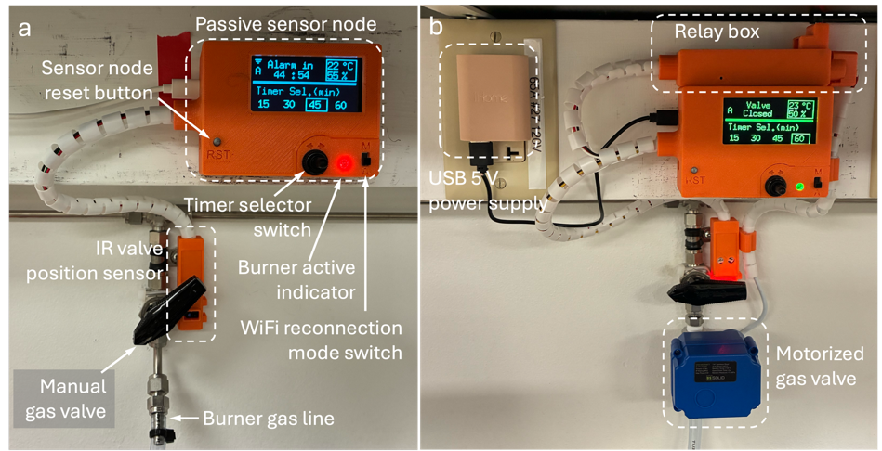

Figure 1. Sensor Node.

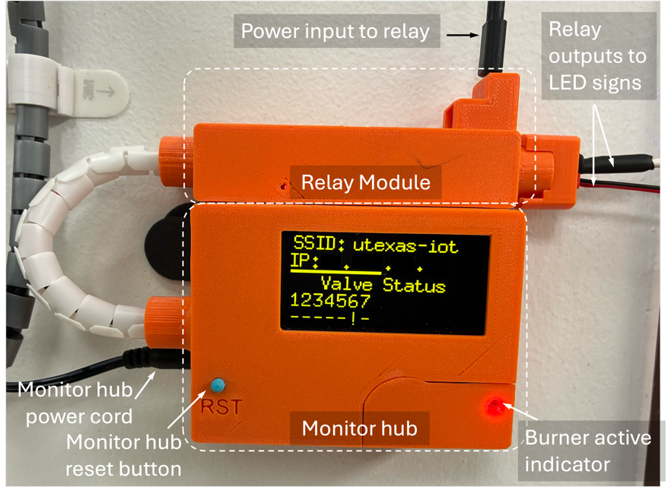

Figure 2. Methane Valve monitor.

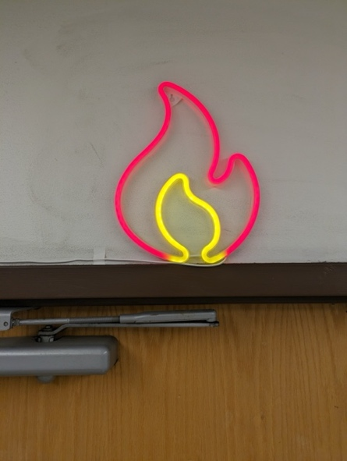

Figure 3. LED signage above the entrance within CPE 4.428.

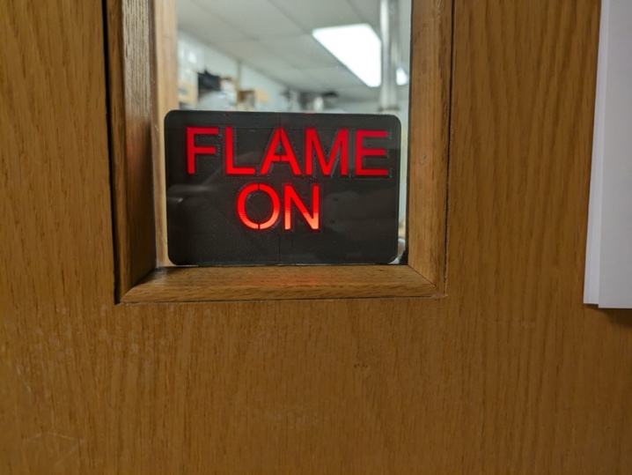

Figure 4. LED signage on the door of CPE 4.428.

**Sensor node functions**

* Display Features
  + Wi-Fi state.  -> Wi-Fi is connected, * -> Wi-Fi disconnected. The symbol blinks every 1 s as the heartbeat indicator.
  + Valve position. Displays the sensed valve position. Indicator: green -> closed, red -> open.
  + Ambient temperature (°C) and relative humidity (%.)
  + Timer countdown bar. Shows the remaining time as the length of the bar.
  + Timer selection. The selected timer duration has a square border.
* Wi-Fi Reconnection Mode Switch
  + Auto: The sensor will automatically join the programmed Wi-Fi network every 60 s, if not joined. The sensor will freeze for ~ 6 s during the reconnection.
  + Manual: The sensor will only join the Wi-Fi network when starting up.
* Timer Control Switch

Navigate to set the desired timer duration (in minutes).

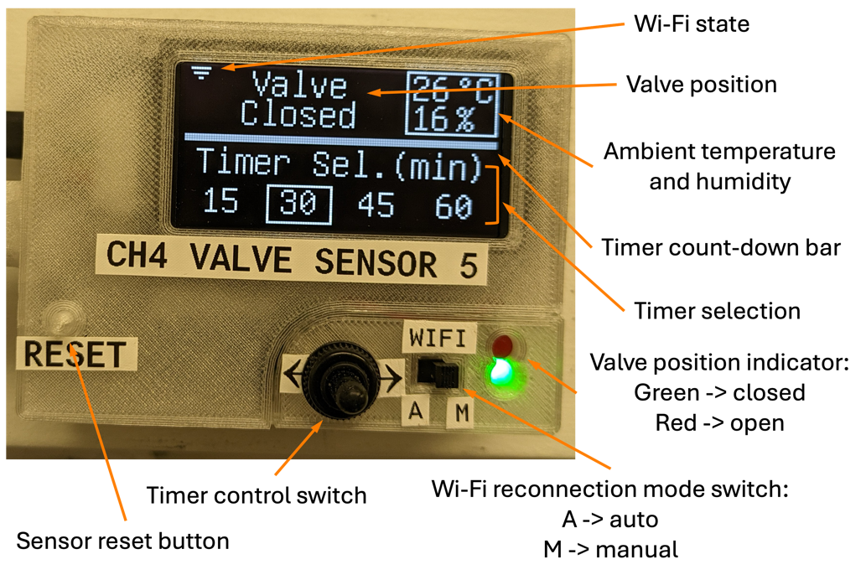

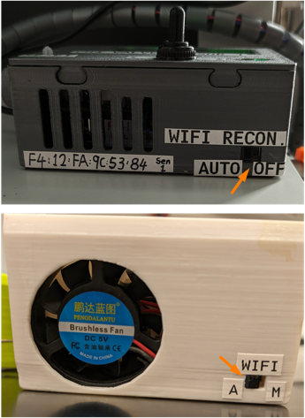

Figure 6. Wi-Fi reconnection mode switch on earlier-version sensors.

Figure 5. Sensor Node main unit.

**Timer functions**

* Start Timer
  + The timer will start automatically upon opening the methane valve.
  + The Valve position indicator will turn red when the valve is opened.

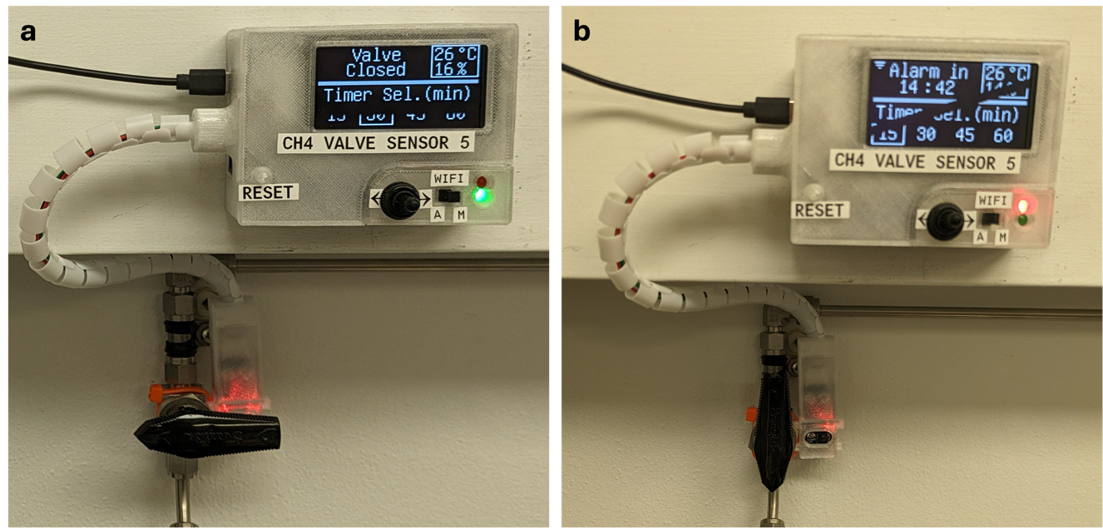

Figure 7. Sensor node with the valve in (a) open and (b) closed state.

* Reset Timer
  + The timer can be reset by blocking the valve sensor with objects (e.g. pipette, hand, etc.)
  + Darker objects might not trigger the IR sensor as effectively, due to lower IR reflection, compared to brighter-colored objects.

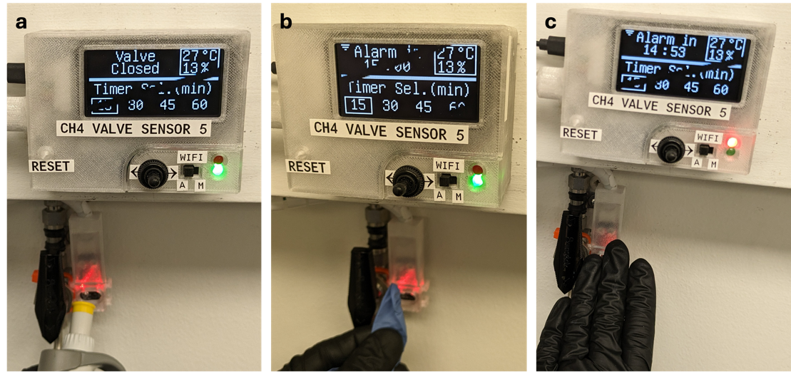

Figure 8. Resetting the timer with (a) a pipette, (b) a blue glove, and (c) a black glove.

**Automatic gas shutoff**

The passive mode functions are retained. Additionally, the sensor would shut off the gas line 10 minutes after the alarm timeout. During actuation, a 10-s lockout prevents further input to allow full closure of the motorized gas valve. To safely reactivate after shutoff, follow the display instructions.

* Close the manual valve, and
* Toggle the timer selector twice (confirmation gesture).

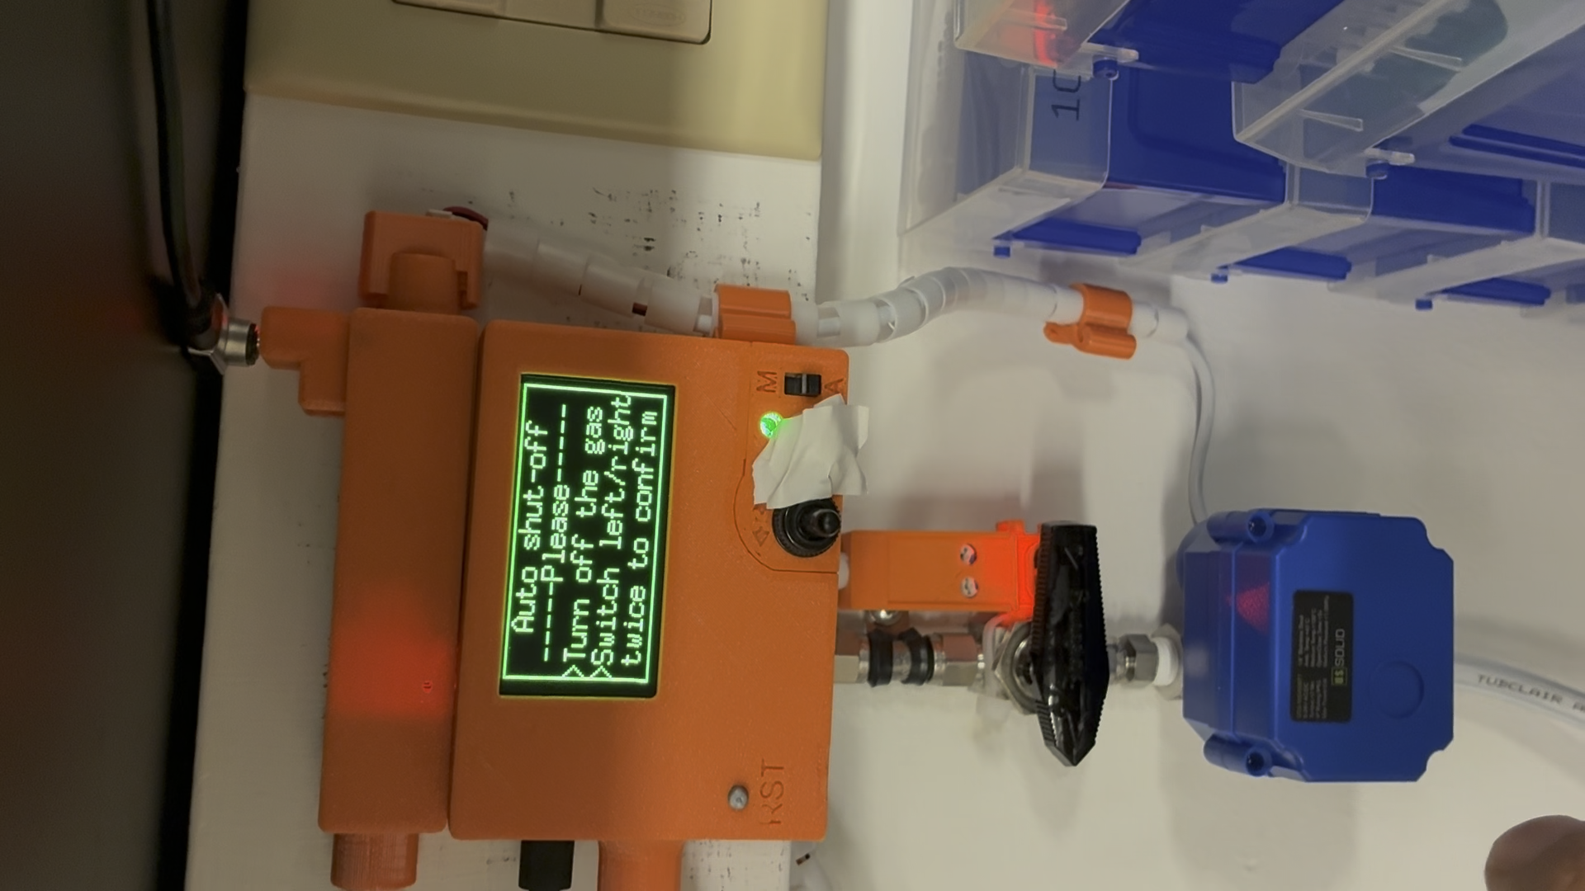

Figure 9. Auto shutoff recovery instructions displayed on sensor node screen.

**Monitor Hub Functions**

* Relay Module

The relay box is a snap-on module to allow the sensor node or monitor hub to control power-demanding or higher voltage (> 5V) peripherals. An adjustable USB-PD (power delivery) trigger module is used to allow user to select the appropriate voltage (e.g. 12 V motorized gas valve, 5 V LED signs).

* Screen
  + Network name. The target Wi-Fi SSID.
  + Monitor’s IP address. Assigned IP address, used for remote access (HTTP).
  + Heart bit bar. Grows incrementally to indicate the program is running correctly.
  + Valve status. The first line displays connected sensor ID in hexadecimal.

The second line displays the corresponding valve position, “-” -> valve closed, “!” -> valve open.

* Relay control signal indicator

On -> relay close signal sent, LED signs should be on;  
Off -> relay open signal sent, LED signs should be off.

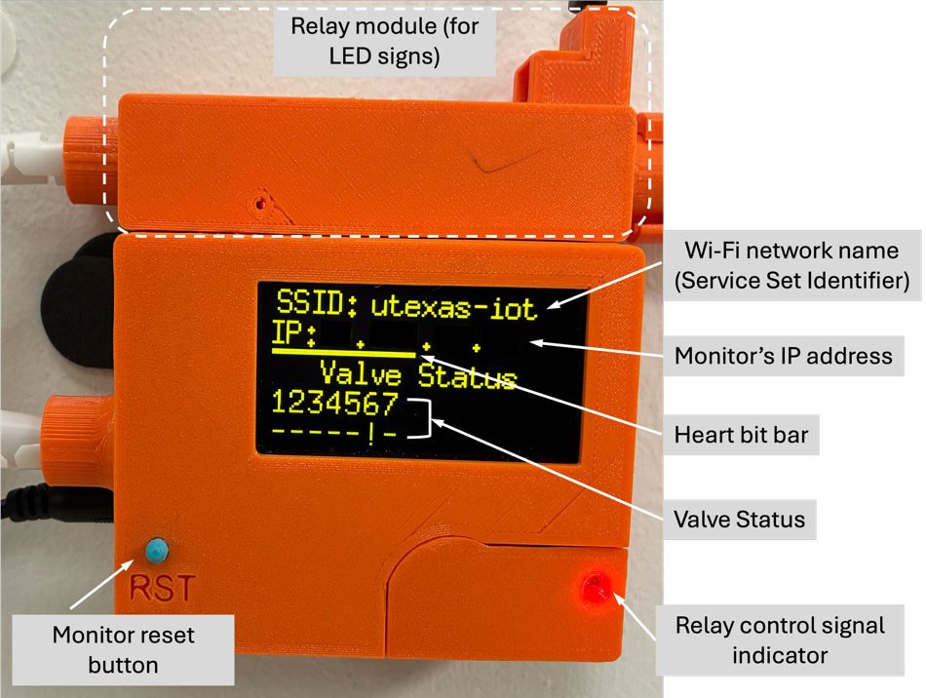

Figure 10. Methane Valve Monitor unit.

**Desktop Display Node**

The real-time burner status is shown on the e-ink screen of the display node. Three sensor statuses can be displayed: ‘close’ for closed valve (inactive burner), ‘open’ for opened valve (active burner), ‘TMO’ for alarm timeout status in active burners. If a sensor timeout is received, the backlights of the display node would flash.

The display node is mobile and powered by a lithium-ion cell, enabling uninterrupted operation without an external supply.

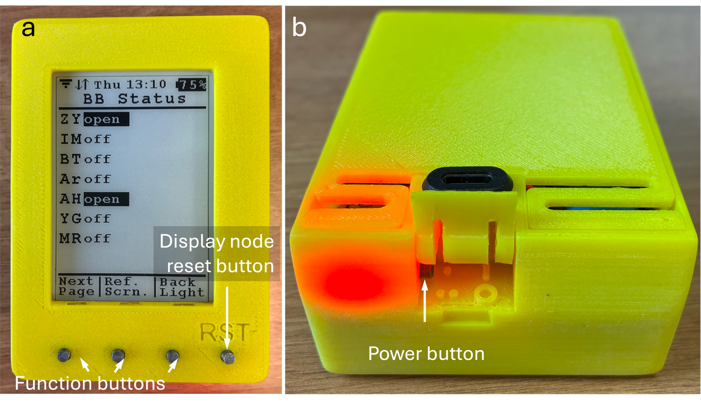

Figure 11. Desktop display node. (a) Front view showing two active Bunsen burners. (b) Rear view of the unit.

**Sensor Mapping**

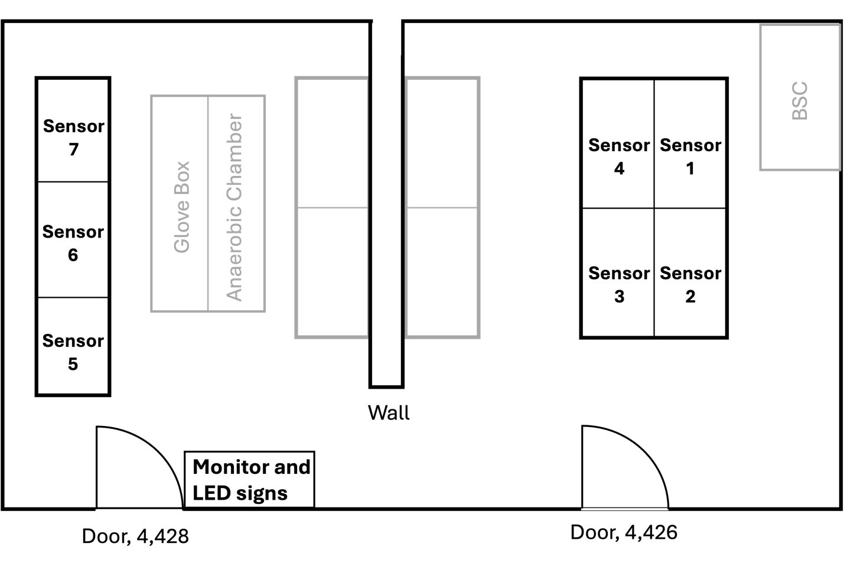

Figure 12. Methane Valve Sensor and Monitor map. As of Jan, 2024, seven sensors are installed.

**Remote Connection**

Access the sensor status remotely by establishing an HTTP connection with the monitoring device, via internet browser on the remote devices (smartphones or computers).

The access password is shared on the group Wiki/Safety page.

On-Campus:

* Connect to the ‘utexas’ Wi-Fi network or an ethernet port on campus.
* Open a web browser, in the address bar, enter the monitor’s IP as displayed on the monitor hub.

Off-Campus:

For remote access outside the campus, please use the [University VPN Service](https://wikis.utexas.edu/display/engritgpublic/Connecting+to+the+University+of+Texas+VPN).

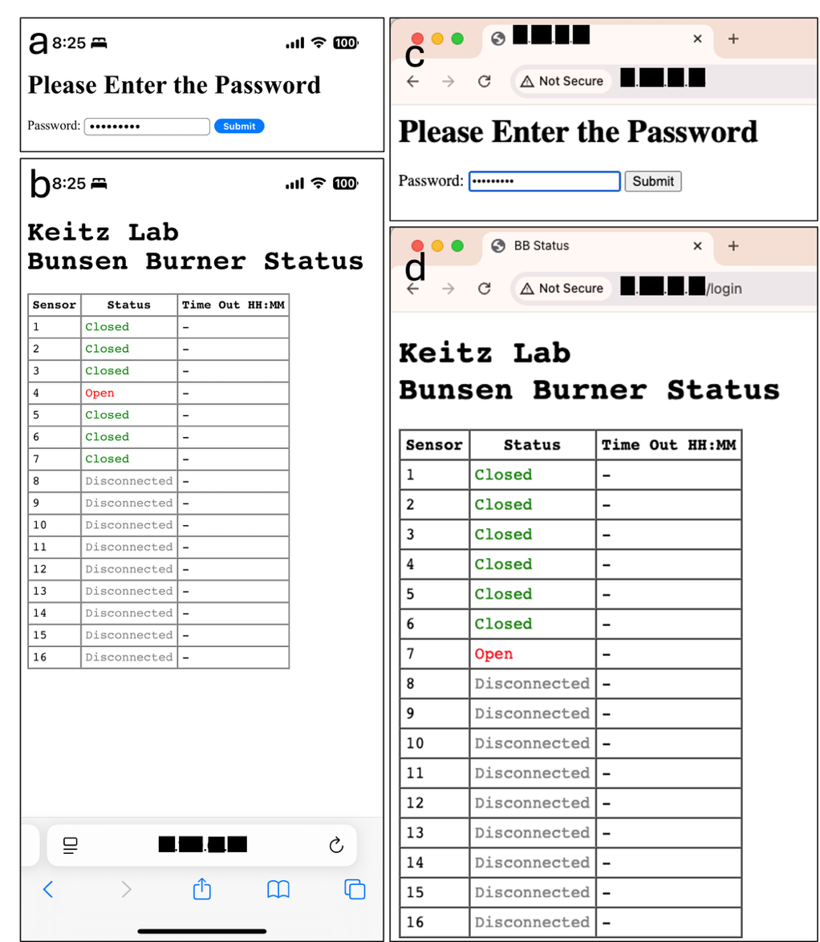

Figure 11. Screen-shot of the remote HTTP connection interface.

**Troubleshooting**

* **Sensor node freezes**.

**Solution**: Reset or restart the sensor by pressing the reset button or unplug then plug in the USB power supply.

* **Sensor node responds slowly**.

**Solutions**:

* + Reset or restart the sensor by pressing the reset button or unplug then plug in the USB power supply.
  + Switch the Wi-Fi reconnection mode to Manual (M).

**Possible causes and notes**:

* + The sensor will freeze for ~ 6 s during Wi-Fi connection, which occurs every 10 s in Auto (A) mode. This could lead to periodic freezing if Wi-Fi connectivity is unstable.
  + Setting the mode to Manual (M) can prevent periodic freezing.
  + Without a Wi-Fi connection, the sensor will not activate the LED signs nor be seen from remote access.
* **Monitor hub cannot receive any sensor data (while sensors are connected to the Wi-Fi network).**

**Solution**: Reset the monitor hub. If the hub IP changed and failed to establish connection with sensor nodes, flash the node firmware with the new hub IP.

**Possible causes and notes**:

* + Currently, the "utexas-iot" network does not support static IP assignment, which may lead to IP changes after restarts or network resets.
  + An automatic recovery mechanism is implemented. In the rare event that both the sensor and the hub restart and receive new DHCP addresses simultaneously, auto-recovery cannot re-establish the link.
* **Cannot remote access the monitor**.

Solution: Verify the monitor’s IP is correct (may change over time due to restarting or network reset).

* **Display node screen is not responding/date is wrong**.

Solution: Rest the display node.